A SHORT FORM FOR HOLY BAPTISM
IN CASES OF NECESSITY

In urgent cases, in the absence of the Pastor, any Christian may administer Holy Baptism.

Take water, call the child by its name, pour or sprinkle the water on the child, saying:

I baptize thee in the Name of God the Father, and of the Son, and of the Holy Ghost. Amen.

If there is time, the baptism may be preceded by the following prayer:

Eternal, merciful God! We pray Thee extend Thy goodness and mercy unto this child who now asks; open the door to it who knocks, that it may enjoy the everlasting blessing of Thy heavenly washing, and may come to the eternal kingdom which Thou hast prepared through Christ, our Lord! Amen.

Our Father who art in heaven. Hallowed by Thy name. Thy kingdom come. Thy will be done on earth as it is in heaven. Give us this day our daily bread. And forgive us our trespasses, as we forgive those who trespass against us. And lead us not into temptation. But deliver us from evil. For Thine is the kingdom, and the power, and the glory, forever and ever. Amen.

Evangelical Lutheran Hymn Book (1918)
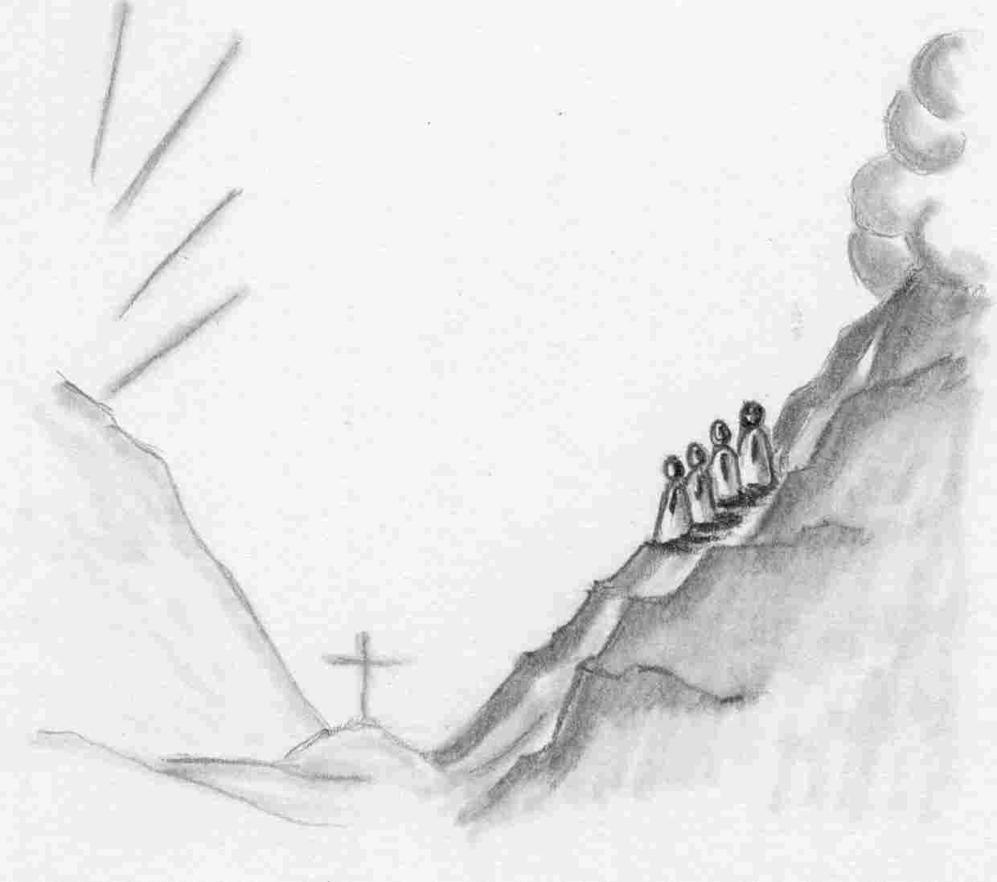

Tell no one the vision, until
the Son of Man is raised from the dead.

Our Redeemer Lutheran Church
403 South Hayes
Emmett, Idaho 83617 Church: 208-365-5231

Pastor: Rev. Michael L. McCoy
parsonage: 208-365-5214
email: mmccoy19@earthlink.net
www.scholia.net – the website for:
Good News for the Diaspora!
Music, Litany and Sermons for the Diaspora!
scholia.net publishing – Where the Word is not Bound
Predici in limba romana – (Sermons in Romanian)
The artwork is by Sharon Geiser.
Permission to use this copyrighted graphic is limited to congregational use.

This bulletin cover provided by www.scholia.net and is made available without cost.

6 February Anno Domini 2005

The Transfiguration of Our Lord

Tell no one the vision, until
the Son of Man is raised from the dead.
To place the graphic on this page:
Copy the graphic on the previous page.
Click on the open space above and a graphic box should appear. Paste the graphic.

Change this frame and the box above by clicking the body of the text and adding the particulars. (See the previous page for an example.)
The artwork is by Sharon Geiser.
Permission to use this copyrighted graphic is limited to congregational use.

This bulletin cover provided by www.scholia.net and is made available without cost.

6 February Anno Domini 2005

The Transfiguration of Our Lord

A SHORT FORM FOR HOLY BAPTISM
IN CASES OF NECESSITY

In urgent cases, in the absence of the Pastor, any Christian may administer Holy Baptism.

Take water, call the child by its name, pour or sprinkle the water on the child, saying:

I baptize thee in the Name of God the Father, and of the Son, and of the Holy Ghost. Amen.

If there is time, the baptism may be preceded by the following prayer:

Eternal, merciful God! We pray Thee extend Thy goodness and mercy unto this child who now asks; open the door to it who knocks, that it may enjoy the everlasting blessing of Thy heavenly washing, and may come to the eternal kingdom which Thou hast prepared through Christ, our Lord! Amen.

Our Father who art in heaven. Hallowed by Thy name. Thy kingdom come. Thy will be done on earth as it is in heaven. Give us this day our daily bread. And forgive us our trespasses, as we forgive those who trespass against us. And lead us not into temptation. But deliver us from evil. For Thine is the kingdom, and the power, and the glory, forever and ever. Amen.

Evangelical Lutheran Hymn Book (1918)

